SIT302 Project

Installation Guide

Online Book Store



GROUP 6

YOUSEF NAIF A ALHARBI

NOHA JAMALI A SALEM

FAISAL ABDULLAH M BIN GHIMLAS

AHMED AL SHAMISI

ABDULLAH ALDOKHIIL

AVIRAJ KAMBOJ

JALAB JALBANI

# Table of Contents

Table of Contents 2

1.0 Introduction 3

1.1 Document Purpose 3

2.0 Navigation 3

3.0 System architecture 3

4.0 Technologies used 4

5.0 Installation steps 4

5.0 Database installation 5

6.0 Web Server Code Installation 6

7.0 Setup database configuration 6

8.0 Bibliography 7

# 1.0 Introduction

## 1.1 Document Purpose

The purpose of this document is to provide a comprehensive programmer’s guide. This document explains the details that a programmer will need in order to maintain and enhance the Online Book Store system.

# 2.0 Navigation

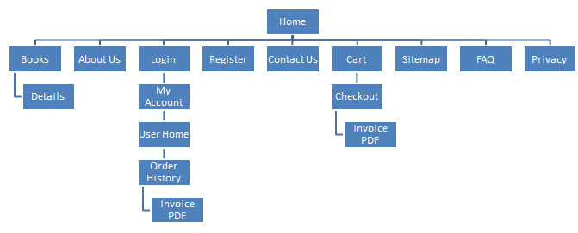

# 3.0 System architecture

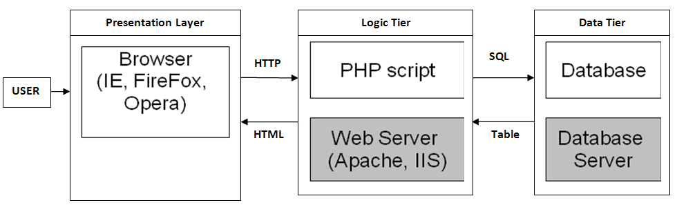

Figure 1: Three tier website architecture

The architecture of the system is standard 3-tier architecture for web systems. The following table explains the components of the system that belong in each of the layers of the 3-tier architecture:

|  |  |
| --- | --- |
| **Architecture Layer** | **System Component** |
| User | The end-user of the system. There are two types of end-users in the system:   1. The shoppers who will access the front end of the system 2. The administrators (the business owners) who will manage product catalogues, order history and will be responsible for shipping orders |
| Browser | The web browser will be the client side software used to access the system (both the front-end and the administration section). |
| PHP Script | The PHP scripts will be the native PHP code and the PDO libraries to render the administration section and the front-end to the users. |
| Database | The database will be a MySQL database that will store all data for the system. |

# 4.0 Technologies used

| **Technology Name** | **Description** |
| --- | --- |
| MySQL 5.0+ | The MySQL Technology has been used for the database.  Uses MySQL for all data storage including configuration data, user data, product data and order data.  The MySQL 5.0+ version is used.  The testing has occurred for at least MySQL 5.0 and MySQL 5.5. |
| PHP 4.0+ | The PHP Server Side programming language is used for rendering server side information and developing the shopping cart.  Objective oriented PHP should have been used.  The view, model and data have been clearly separated. |
| PDO PHP Database Library 3.0+ | The PDO Database library has been used to protect against the database sq. injection attacks. |

# 5.0 Installation steps

The MVC model for code development has been used for the purpose of this project. The following example explains the general coding structure used in the website development.

| **Task** | **Task Details** |
| --- | --- |
| Purchase domain name | A domain name will need to be purchased, e.g. from GoDaddy.com |
| Purchase database hosting | Database hosting will need to be purchased. The database hosting must be MySQL. Minimum space of 100MB will be needed. |
| Purchase web hosting | File hosting will need to be purchased. Minimum of 500MB of file storage will be required. |
| Link the domain name to the hosting | The name servers are provided by the domain name hosting. These domain name servers will need to be linked to the hosting. |
| Setup FTP accounts on the web server | An FTP account will need to be created so that files can be uploaded and downloaded to the web server. |
| Upload the PHP code to the server. | Using the FTP client (e.g. FileZilla), upload the provided PHP code to the web server. |
| Create and setup the database | Create a database on the database hosting  Setup a user account for the database  Update the configuration file in the provided web code and put the host, database name, user and password in it  Run the provided dbscript.sql |

# 5.0 Database installation

1. Go to PhpMyAdmin

2. Go to “Databases”

3. Enter the database name,e.g. “shopping_db”

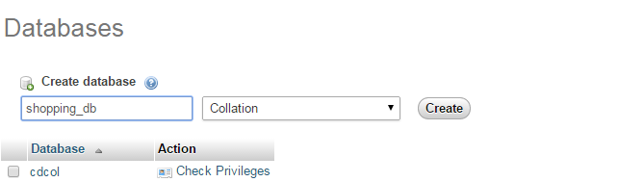

Figure

4. Once the database has been created, select the database from the left hand side navigation bar.

5. Now open the database script provided, “shoppingdb.sql” and copy all of the contents so that they are in the clipboard.

6. Go to the “SQL” table and paste the contents.

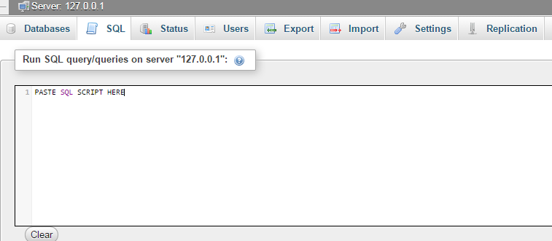

Figure 3

7. Click on “Go”

8. Now the database has been setup.

9. Go to the database to ensure that the following tables have been setup correctly.



Figure 4

# 6.0 Web Server Code Installation

1. Copy the provided folder “assignment”

2. Paste the folder into c:\xampp\htodcs (or the base folder of the web server)

# 7.0 Setup database configuration

1. Open the file “includes/db.inc.php”

2. Now change the following three components of the database.

try

{

$pdo = new PDO('mysql:host=servername;dbname=databasename', 'username','password');

$pdo->setAttribute(PDO::ATTR_ERRMODE, PDO::ERRMODE_EXCEPTION);

$pdo->exec('SET NAMES "utf8"');

}

catch (PDOException $e)

{

$error = 'A connection with the database failed.'.$e;

include 'error.html.php';

exit();

}

**Server Name** The server name is localhost if the database and the web server are on the same box. Otherwise, the hosting provider will provide a server name.

**Database Name** The database name is the database name created in the previous step.

**User Name** The user name for database.

**Password** The password for database.

# 8.0 Bibliography

Ideal Software, Installation Guide Template, accessed on 18 January 2015 at <https://doc.ez.no/content/download/24948/102690/version/3/file/ezflow_setup-1.1.pdf>